**Karachi:**

Russian Beach

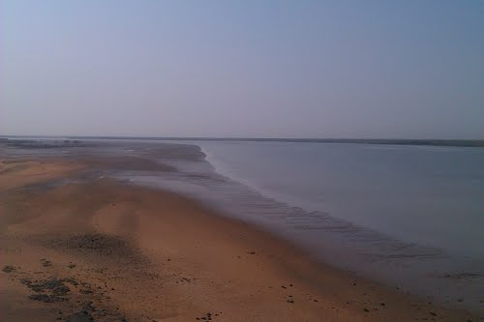

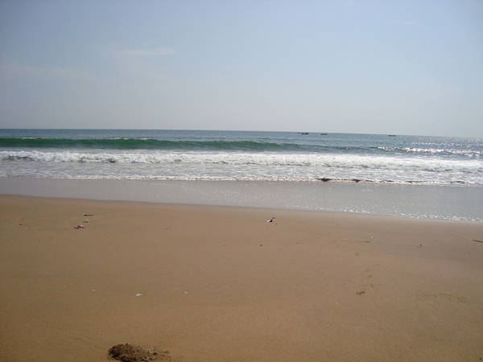

Russian beach is in Mazar Rd Bin Qasim Town, Karachi. Pakistan Steel Mill was created with the help of Russia. This part of the land was selected as a leisure spot for Russian Engineers who came to Pakistan as part of the technical swap, but it doesn’t happen. This beach is very striking for those people who have some interest in fishing. It has too many beautiful huts where you can go with your family for snorkeling and scuba diving.If your boring schedule is making you feel exhausted and you are enthusiastically looking forward to getting free from the rat race, then it’s time for you to allow yourself a break and have fun on the beaches of Karachi.